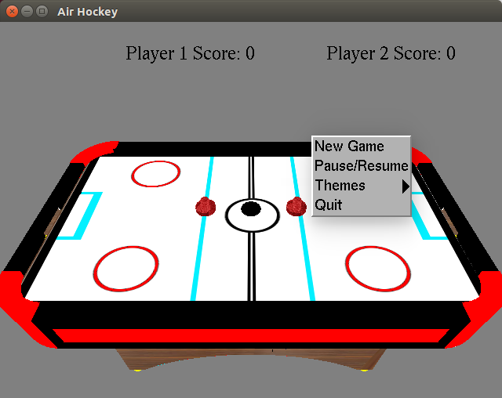

**To build and run the program:**

*cd build* Then: *make*

The executable will be put in the “bin” directory.

*cd bin* Then: *./AirHockey*

**To clean (removing object files and executables):**

*cd build* Then: *make clean*

**Description**

The purpose of this assignment is to produce a 3D simulation of Air Hockey that is as realistic to the actual game as possible, yet still being a playable and an enjoyable experience for the end user. Human vs Human, Human vs AI, and Team vs Team are the modes in this game. Difficulty can also be changed. Goals are to the left and right boundaries of the table, and a sound will play if a goal is scored. First to 7 points wins.

**Controls and modes**

***Human vs Human***

Activated by default, can be activated by menu. To bring up menu, use right mouse button. The game is then played using the keyboard and mouse. Player 2 can use the mouse as well. They control their paddle by left click and holding it down.

***Human vs AI***

Activated by using menu. To bring up menu, use right mouse button. The player must use the mouse to play.

***4 player mode***

Activated by using menu. To bring up menu, use right mouse button. The mode is then played using two PS4 controllers. The left team uses the left joysticks to control their paddles, and the right team uses the right joysticks to control their paddles.

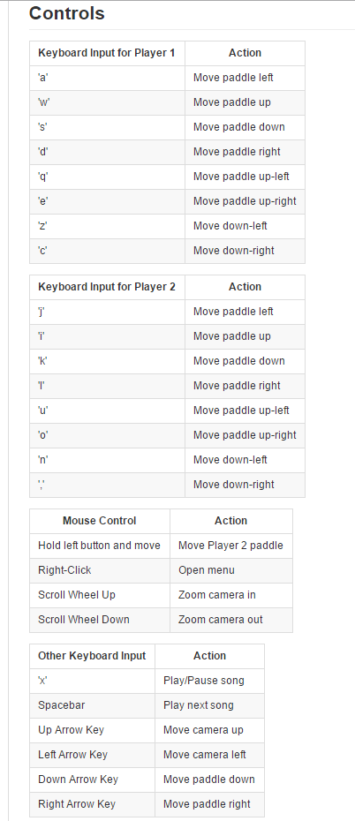

|  |  |
| --- | --- |
| **Difficulty** | **Action** |
| 1 | Slow |
| 2 | Medium |
| 3 | Fast |

**Extra Credit:**

* Multiple Themes
* Music/Audio
* Human vs Human mode (2v2)
* Human vs AI mode
* PS4 Controller support
* 4 Player Mode
* Multiple difficulties (varying puck speeds)

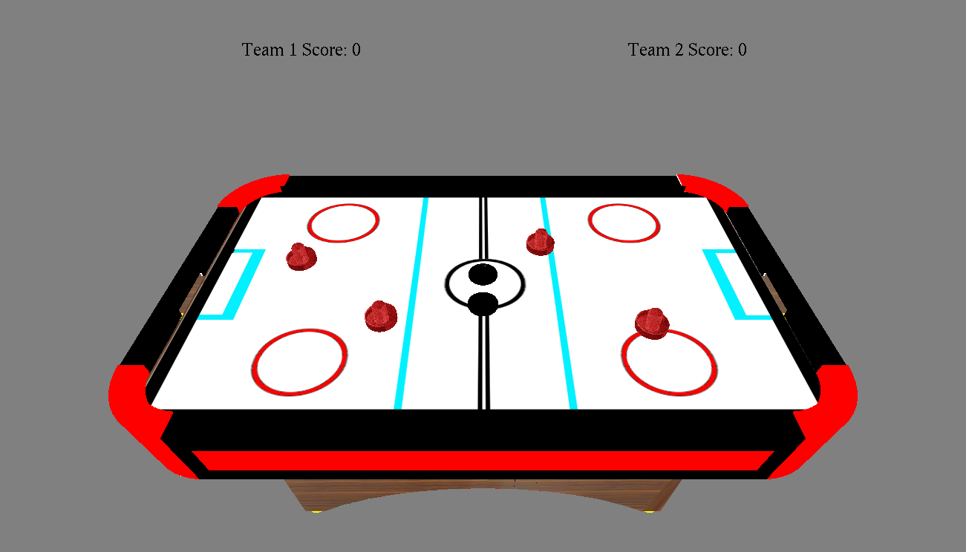

**Air Hockey**

*By Truman Chan, Martin Revilla, Marco Rivas*